Jabgang - Cane (Plectocomia Himalayana) Management & Marketing Plan
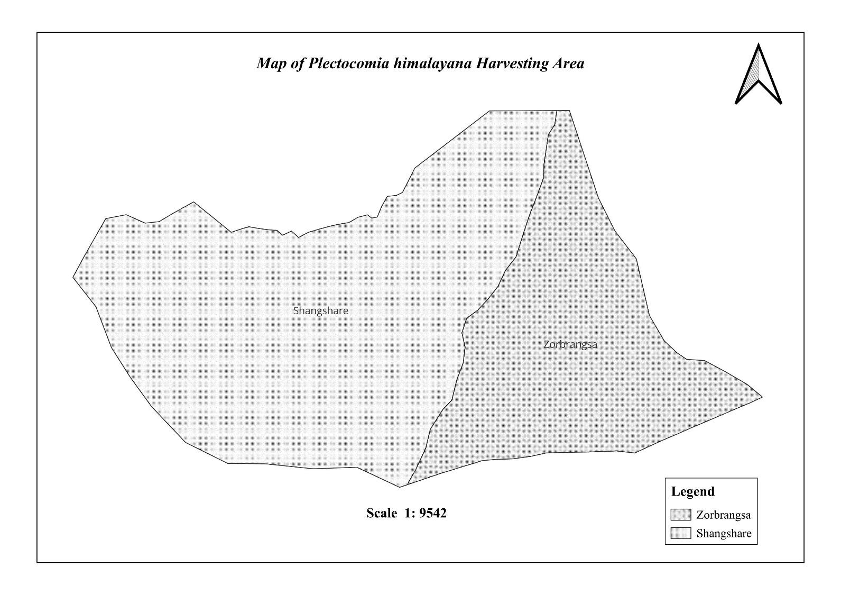
(3rd Revision)

Shelrimuhung Gewog
Mongar Dzongkhag
Plan Period: 2025-2035

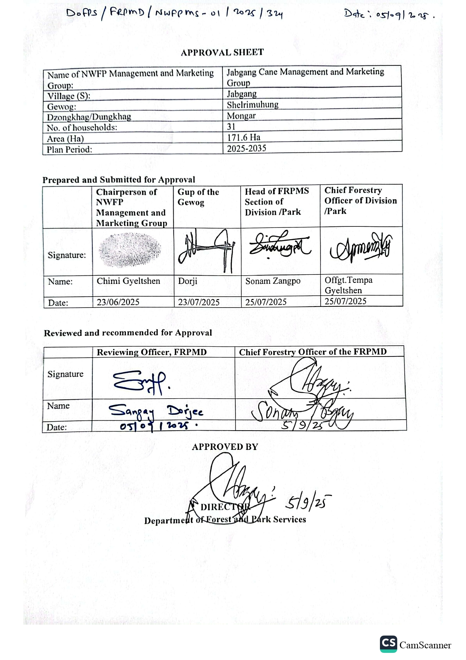
Contents
Acronyms i
Summary of Completion Report of Jabgang - Cane Management Plan iii
Physical Achievement iv
Financial achievement iv
Recommendation iv
PART A: NWFP MANAGEMENT AND MARKETING PLAN 1
Background 1
2. Goals and Objectives 2
3. Description of NWFPs Present in the area demarcated for management 2
3.1 Description of Block 2
3.2 Block I - Zor-brangsa 3
3.3 Block II - Shangsha-ree 3
3.4 Description of Cane and resource assessment 3
3.4.1 Cane 3
3.4.2 Resource assessment 3
4. Projection for AHL of cane for domestic use and commercial sale. 4
5. Prescriptions for sustainable cane harvesting 4
6. Marketing and sales plan 6
7. Marketing procedures and arrangements 6
8. Benefits to the members 7
PART B: GROUP’S BY-LAWS 8
10. Name of NWFP group: Jabgang - Cane Management and Marketing Group. 8
10.1 Membership arrangement 9
10.1.1 New membership 9
10.1.2Withdrawal from membership 9
11. Executive committee of the NWFP management and marketing group 9
11.1 Chairman 9
11.2 Secretary 9
11.3 Treasurer 10
11.4 Terms of reference for group members 10
12. Tenure of committee member 10
13. Incentive for committee members 10
14. Source for the generation of the group fund 10
15. Group fund management and utilization 11
16. Conflict resolution 11
17. Meeting and purpose 11
18. Penalties 11
19. Roles of BWS 12
ANNEXURE I: Application i

Acronyms
AHL Annual Harvesting Limit
BWS Bumdeling Wildlife Sanctuary
BL Backload
BDBL Bhutan Development Bank Limited
CDF Community Development Fund
CFMG Community Forest Management Group
DoFPS Department of Forest and Park Services
ECM Executive Committee Members
Nu. Ngultrum
NWFP Non-Wood Forest Products
NWFPMG Non-Wood Forest Products Management Group
SPRO Serzhong Park Range Office
SRFL State Reserve Forest Land

Brief Report on Previous Jabgang Cane Management Plan (June 2019 to June 2024)

Physical Achievement
- Significant improvement in resource use and management. Cane harvesting is done in adherence to the management plan, ensuring sustainable resource use and protection.
- Proper maintenance of records, books, and accounts helped in strengthening group cohesion and transparency.
- Generated income from the sale of cane and accumulated in the group account fund from which members had availed soft loans to support and enhance their livelihood.

Financial achievement
Table 1. Financial achievement of the group from 2019 to 2024
Year | Product | Price/unit (Nu.) | Quantity sold (BL) | Income (Nu.)
2019-2020 | Cane | 690 | 33 | 22770
2020-2021 | Cane | 690 | 33 | 24750
2021-2022 | Cane | 750 | 33 | 19500
2022-2023 | Cane | 780 | 25 | 18720
2023-2024 | Cane | 780 | 14 | 10920
Total |  |  | 162 | 119430

Recommendation
- Periodic technical Support and backstopping from Serzhong Park Range Office in books and records keeping, implementing workplan, conflict resolution, monitoring, and evaluation.
- Upskill members to diversify the cane product and venture into a new cane craft business.
- Develop a marketing strategy for a regular and organized market.
- Exposure to other successful NWFP groups to learn and adapt new skills and knowledge.

PART A: NWFP MANAGEMENT AND MARKETING PLAN

Background
Jabgang–Cane Management and Marketing Plan is prepared with the aim of conserving cane resources and enhancing people’s livelihood, and as such, all activities and strategies are aligned towards achieving this objective.
The first management plan was approved in 2011 and implemented until 2019, followed by a second plan that extended from 2019 to 2022. This plan marks the third revision and builds upon the success and lessons learned over time in managing both the resource and the group.
A total of 171.6 hectares of State Reserved Forest (SRF) land is allocated for the management of cane by 31 household members from the villages of Jabgang, Thilling, Thramo, and Yarab. The cane management area lies within the buffer zone of Bumdeling Wildlife Sanctuary (BWS) under Jabgang Chiwog, and is divided into two blocks: Shangsha-re (112 ha) and Zor-brangsa (59.6 ha). This division facilitates the smoother implementation of group activities and supports the long-term conservation of cane resources.
Over the past thirteen years, the group has generated a fund of Nu. 210,210.43, and successfully protected the cane resources from over-exploitation, both from within and outside.
Cane was once harvested extensively by people from nearby and distant communities for its edible shoot, prized as a bitter vegetable, and for its stems, which are used to make ropes, tie fences, and weave baskets. This led to overharvesting and depletion. Domestic and agricultural needs account for most of the consumption, as seen in the scarcity of canes near villages and paths.
To ensure effective monitoring and long-term sustainability, the group has agreed to limit cane harvesting to two designated days per year, during which all members will participate. Each member is required to contribute one backload of split cane stripes to the group. And, if a group member desires, additional backload may be collected for personal use. Payment for the collection permit shall be paid as per this management plan.
On average, split stripe cane from five mature cane stems yields one backload. One backload refers to the amount of split cane used to weave three rough baskets, as per the locally accepted measurement standard.
The collection of cane shoots for vegetables is strictly prohibited. Split cane stripes are sold directly to people within the gewog, and any surplus is marketed to Chaskhar and Yadi by the group’s management committee. Despite the wide use of cane products, particularly the baskets by people, there is no organized or regular market. The group will adopt two modalities: a) Auction by group, or b) Direct sale through negotiation.
The revision of this management plan, including resource assessment and planning, was carried out with active participation from group in accordance with various guidelines and rules, including the Framework for Management and Marketing of Non-Wood Forest Products 2022, the Nature Conservation Act of Bhutan 2023, the Forest and Nature Conservation Rules and Regulations 2023, and the Forest and Nature Conservation Code of Best Management Practices in Bhutan.
This plan consists of two parts: the first part covers management aspects, while the second outlines the group’s by-laws. Given the significance of cane resources to the group, the preparation and implementation of this management plan is a crucial step toward achieving economic benefits and ensuring long-term sustainability of the cane resource.

2. Goals and Objectives
This management and marketing plan aim to achieve the following objectives:
- Sustainable utilization of cane and derive equal benefits among members
- Protect the cane resource from illegal harvesting, minimizing the risk of resource exhaustion.
- Generate income through the sale of cane and enhance their livelihood
- Take ownership and responsibility for the use and management of the cane resource, including decision-making.

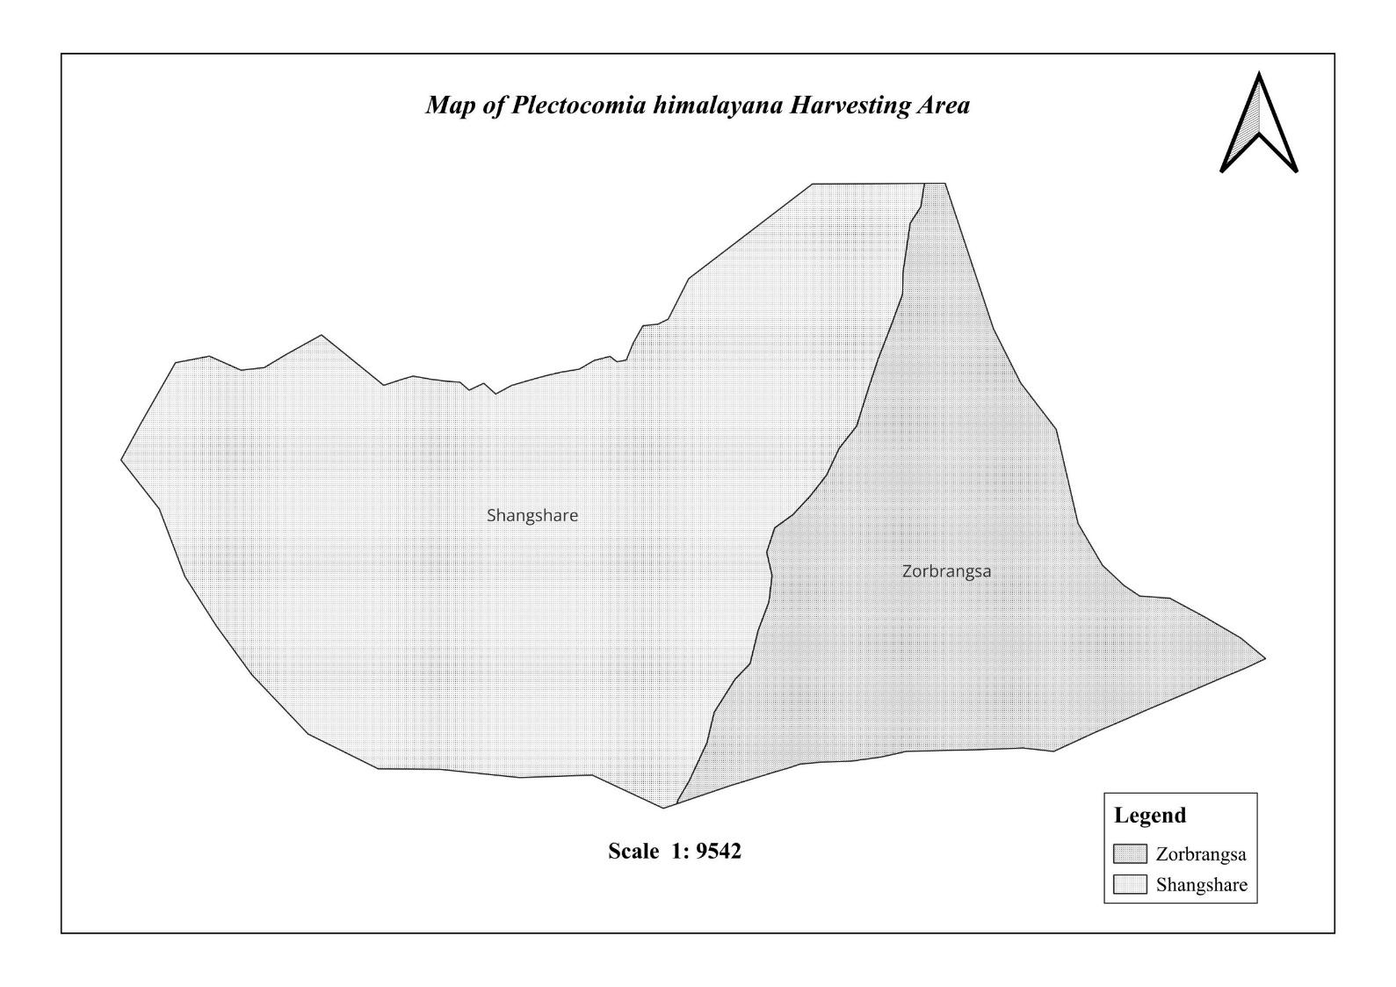
3. Description of NWFPs Present in the area demarcated for management
Figure 1. Cane Harvesting Area Map

3.1 Description of Block
The cane collection area spans 171.6 hectares and is divided into two blocks. The forest is divided into blocks primarily for ease of management, which entails harvesting and protection. These blocks have an altitude range of 1625 to 2210 masl. Tree species such as Alnus nepalensis, Toona cilata, Nyssa javanica, Michelia doltspa, Betula alnoid, Acer campbellii, Shima wallichii, and Persea sp are some of the dominant species.

3.2 Block I - Zor-brangsa
This block has an area of 59.6 ha with scarce cane resources. Lack of proper management and protection has led to the depletion of resources over time in this block. This block is relatively accessible to people as numerous cow herders’ hut is located and these camps are occupied for almost all year.

3.3 Block II - Shangsha-ree
Covering an area of 112 hectares, the Shangsha-ree block has a considerable abundance of cane resources. To replenish and restock the Zor-brangsa block, this plan period will focus on maximizing the backload of cane that will be harvested from this block.

3.4 Description of Cane and resource assessment

3.4.1 Cane
No other species of cane, besides Plectocomia himalayana, is found within the forest. With diverse use, the cane is collected by group members for both domestic use and commercial sale.

3.4.2 Resource assessment
“Guideline for resource assessment and management of Cane, DoFPS 2011” was followed for resource assessment with active participation of NWFP group members. Accordingly, the harvesting area was delineated and mapped on Google Earth and QGIS, in consultation with members, both in locating the area on the map and physical field validation. This was carried out based on the availability of cane resources, traditional boundaries, and customary resource management practices.
Bock I (Zor brangsa)
Block Area: 147.27 ac OR 59.6 ha (a)
The total number of plots measured in block I is 60 plots (one percent of the block area).
Therefore, total area of plots = (No. of plots measured in bock X 100 m²)/10000 m²
i.e., 60 plots X 100 m²/10000 = 0.6 ha or 1.48 ac (b)
Table 1. Number of canes in Zor-brangsa block and AHL
Time period for harvesting of canes | Sub-block (sub block area=a; sample area covered = b)
 | Number of canes in sampling area (c ) | Canes per acre (d) (= c/b) | AHL of cane stems per block (e)  (= a*d) | AHL of back load per block(f) (=e/average number of canes per back load)
Year1-2 (present estimated length: ≥ 15m) | 42 | 28 | 4116 | 823 ( 5 stems per backload)
Year3-4 (present estimated length: 10-14.9m) | 30 | 20 | 2940 | 588
Total | 72 | 48 | 7056 | 1411

Block II - Shangsha-ree
Block area: 112 ha OR 276.76 ac (a)
Total number of plots measured in block II is 112 plots (one percent of block area).
Therefore, total area of plots = (No. of plots measured in block X 100 m²) / 10,000 m²
i.e., (112 plots X100 m²/10,000 = 1.12 ha or 2.77 ac (b)
Table 2. Number of canes in Shangsha-re block and AHL
Time period for harvesting of cane for handicraft/cane shoot | Number of canes in sampling area (C ) | No. of canes per acre (d) (=c/b) | AHL of cane stems per block (e) (=a*d) | AHL of back load per block(f) (=e/average number of canes per back load)
Year1-2 (present estimated length: ≥ 15m) | 66 | 24 | 6624 | 1324 (5 stems per backload)
Year3-4 (present estimated length: 10-14.9m) | 42 | 15 | 4151 | 830
Total | 108 | 39 | 10775 | 2154
Although a backload is ambiguous unit of measurement, it facilitates to understand annual harvesting limits and also the members can apprehend the quantity quite clearly.

4. Projection for AHL of cane for domestic use and commercial sale.
Sale of cane and its products will be organized only through group - either by auction or direct sale (through negotiation). In case of direct sale, the executive committee members of cane management group will explore potential market within Bhutan for sale of cane and its products.
Table 4. Annual harvesting limit and harvesting areas of cane
NWFP Name | Harvesting area(s)  (name) | Parts harvested | Use purpose (traditional & others) | Harvesting season | Estimated quantity for harvest in a year
Plectocomia himalayana  Phashi (Ts) or Patsa (Dz) | Shangsha-re block & Zor-brangsa block | Stem | Mature stems for handicrafts, basket, and rope. | November OR December | - 155 number of matured stems, equivalent to 31 BL for sale.  - 155 number of matured stems, equivalent to 31 BL for domestic use by members.

5. Prescriptions for sustainable cane harvesting
To ensure a sustainable harvest of cane from the collection area, the following harvesting procedures shall be strictly followed for both domestic and commercial harvests.
- Members must come together on a specific date (date fixed by the executive committee) for harvesting and collection. This engagement of collecting, harvesting, or transporting canes within a single window together will render easy monitoring, recording, and build trust and transparency among the group members, besides helping and supporting.
- Cane shall be harvested during October or November as scheduled by ECM, both for commercial and domestic purposes, based on the harvesting prescription and AHL.
- Annually, each member shall contribute one backload of canes to the group for sale. And another one, if desired, for self-consumption.
- Member must get a collection permit before harvesting the cane.
- Collection of cane shoots for vegetables shall be strictly prohibited.
Table 2. Specific Prescription for the sustainable harvest of cane
NWFP | Prescriptions for sustainable harvesting
Plectocomia himalayana (Phashi) | For mature stems  Cut cane stems only when mature, which is characterized and recognized by:  - Loosening of the leaf sheath from the lower part of the cane stem  - Exposure of the lowest part of the stem,  - Turning yellow-reddish along the entire cane length  - An estimate cane length of 15m (or usable length of about 10 m)  - Harvest during winter, as canes have a better quality during this season (lower water content and more durable)  - Harvest the over-matured cane to stimulate the regeneration of new shoots.  - Retain 10 cane plants of the same species per acre as a seed cane.  - DO not feel the trees that provide support to the cane.  - Pull down the cane as much as possible from the supporting trees to avoid resource waste.  - Do not uproot or damage the rhizome, and cut the stems above the sprouts.  - Cut only lateral cane stems.  For cane shoots.  - Harvest only the lateral shoot; do not cut the main cane stem for shoot collection.  - Cut only the shoots that have no physical support for further development (i.e, is cane growing horizontally over the forest floor).  - Cut the young shoot by bending the cane with the strong hook stick.  - Cut the lateral shoot diagonally to avoid rotting the remaining cane.  - Do not damage the sucker buds, which will later develop into lateral shoots.

6. Marketing and sales plan
Canes, primarily a raw material for weaving baskets and other cane products, were sold within Sherimung and nearby Ngatsang and Chaskhar gewogs. The group will adopt two selling modalities: a) Auction by group, or b) Direct sale through negotiation. An auction means a public sale in which canes will be sold to the highest bidder. And direct sale means selling of canes directly to the consumer at the negotiated rate.
Table 3. Marketing and sales plan of the group for a year
NWFP | Potential market | Estimated quantity per season  (unit) | Expected price per Backload | Total (Nu)
Cane (Plectocomia himalayana) | Local market | 31 backloads | Nu. 780.00 | 24,180.00

7. Marketing procedures and arrangements
The executive committee members will initiate and coordinate the sale of cane resources either through auction or direct sale.
The following procedure shall be followed;
- Every member of the group will collect a BL of cane on the harvesting date and hand it over to ECM.
- ECM, in collaboration with SPRO, shall initiate the auction of cane. The auction committee shall comprise: a) 3 ECM of the group, b) 1 group member (non-executive committee), and c) a Forest Officer from SPRO.
- Marketing guidelines developed by DoFPS will be referred to whenever necessary.
- If the demand exceeds the harvested quantity, then ECM shall coordinate to harvest the cane to meet the quantity demanded. A maximum of only two days' collection period shall be entertained in a year.
- The executive committee shall explore the market and negotiate the selling price with a potential buyer in case of direct sale.
- Base price will be maintained at Nu 780 per BL of cane, and selling price must not fall below this rate from either of the selling modalities.
- After the sale, the treasurer shall issue money receipts for each payment received.
- The group shall pay commercial royalty to the Forest Office as per the rate fixed by the government.
- Treasurer shall issue money receipts and make payment for transportation charges, Compensation fee to the executive committee for marketing products (Nu. 500 each for three ECM), or any other expenses incurred.

8. Benefits to the members
- The group members shall have equal rights for the collection and utilization of cane for domestic purposes.
- 50 % of the income generated from the sale shall be paid to the members who have contributed the Cane.
- Group members shall have equal rights in decision-making and utilization of funds.
- The group fund shall be utilized for community development, and such a decision must be reached through a 2/3 majority vote of the members.
- Members can avail of soft loans from the group account.
Table 7.Financial projection of benefits to the members from sales (optional)
Sl. No | Particulars |  | Product (names) | Total Amount (Nu)
 |  |  | Cane
1 |  | Revenues
A | Total quantity (unit): 31 BL |  | - | 31
B | Market price |  | - | Nu. 780.00
C | Total revenues from forest product sales (a*b) |  |  | Nu. 24180.00
A | Total revenues |  | Nu. 24180.00
 |  | Expenses
A | Packaging materials |  | - | -
B | Royalty (Nu. 4 per BL for commercial sale) |  |  | Nu. 124.00
C | Transportation cost (lump sum amount of Nu. 1500.00 for two times) |  |  | Nu. 3000.00
D | Compensation fee to the executive committee for marketing products (Nu. 500 each for three ECM for two days) |  |  | Nu. 3000.00
E | Contribution to group account (50%) |  | - | Nu. 12090.00
F | Incidental expenses |  | - | -
B | Total expenses |  | Nu. 18214.00
C | Total benefit (net-income) of group members (total revenues A-total expenses B) |  |  | Nu. 5966.00
D | Average income to group members (C/no of group members) |  |  | Nu. 192.00
E | Price per unit paid to group members (C/1a) |  |  | Nu. 390.00
9. Benefits to the group
Through sustainable management and sales of the cane, 50% percent of the sale proceeds shall be deposited into a group account. Further, the group will benefit from the collection of the membership fees. The further details of the group benefits were outlined in the following tables.
Table 4.2 Financial projection of the benefits to the group, the group fund (optional)
Sl. No | Particular | Amount (Nu)
 | Revenues
1 | Membership registration fees | 3100.00
2 | 50 % Contribution to the group account from sales | 12090.00
5 | Contribution to the group fund from the internal royalty | 3720.00
A | Total revenues | 18910.00
 | Expenses (only include expenses that will be paid from the group funds) | 1500.00 (incentive for ECM)
 | ….
B | Total Expenses | 1500.00
C | Balance: Total revenues-total expenses | 17410.00

PART B: GROUP’S BY-LAWS

10. Name of NWFP group: Jabgang - Cane Management and Marketing Group.
Jabgang Cane Management and Marketing group consists of households from four villages, viz. Jabgang, Thilling, Thramo, and Yarab. There are 31 households from the above villages as members.

10.1 Membership arrangement

10.1.1 New membership
- New settlers and retired public servants with a valid Gung number shall be allowed to join the group upon the payment of an individual share of the total income accumulated in the group fund and membership fee.
- A fragmented family member of a group, whose census and thram along with gung number is transferred separately, shall pay the membership fee to the group from the date of joining.

Withdrawal from membership
- Group members willing to resign from the group shall be allowed. However, he/she shall have no right to claim any benefits such as income generated from the sale of cane and various contributions made to the group.
- He/She shall resign from the group by clearing all the outstanding fees, fines, and any other dues/outstanding.
- Resignation due to permanent migration, resettlement, and old age shall be considered, and she/he shall be paid 50% of his/her share from the total accumulated amount in the group account.

11. Executive committee of the NWFP management and marketing group
The executive committee shall be comprised of three members as follows:
- Chairman,
- Secretary, and
- Treasurer
Every group member shall have equal right to be elected as an executive committee member, provided that he/she can read, write, or shoulder the responsibility. The committee members shall be elected through a democratic process, where the individual receiving the most votes shall be declared elected. Tenure for all three elected committee members shall be for 5 years.

11.1 Chairman
Name and contact number: Tshering (17728875)
Responsibilities of the Chairperson
- Chair all meetings related to this plan.
- Resolve disputes and conflicts among members.
- To arrange and coordinate marketing of canes.
- Impose fines and penalties on the defaulters.
- Counter sign on forms and receipts on collection permits and financial transactions.
- Present annual progress report to the members.

11.2 Secretary
Name and Contact number: Sonam (17727341)
Responsibilities of the Secretary
- Officiate as chairperson during his absence.
- Maintain all records pertaining to Cane management and marketing.
- Maintain minutes of the meeting.
- Issue a collection permit.
- Arrange and coordinate the marketing of canes.

11.3 Treasurer
Name and Contact number: Karma Cheley (77424153)
Responsibilities of the Treasurer
- Collect annual membership fees, fines, and penalties and deposits them to the group account.
- Maintain financial records of the group.
- Prepare and present financial status to group members during the meeting.
- Join the signatory for the financial transaction of the group with the chairperson.

11.4 Terms of reference for group members
All members must monitor and protect the cane management area and report any illegal activity when detected.
- Group members must strictly follow the harvesting prescription as per this management plan while harvesting and must not exceed AHL.
- Carry out patrolling of the cane growing area twice a month during the harvesting season, which falls on October and November.
- Resource shall be collected only during specific months, i.e., October and November, and all the records related to sales must be completed by 15th December.
- Group members must cooperate with ECM with regard to the implementation of the management plan.
- All group members shall have the right to decide on the utilization of the group fund.

12. Tenure of committee member
Tenure for all three elected committee members shall be for 5 years.

13. Incentive for committee members
ECM shall receive a sum of Nu. 500/- each annually as an incentive for the service rendered to the group. Amount for this incentive will be meet from the joint group account held with BDBL.

14. Source for the generation of the group fund
The group shall generate funds through membership fees, collection permits, income from sales, and penalties levied as below;
- Annual membership fee of Nu. 100 annually.
- 50 % of the payment received from the sale.
- Permit fees of Nu. 60 per BL
- Penalty.

15. Group fund management and utilization
- The income generated from the sale of cane and its products, annual membership fees, royalty levied from the collection permit, and fines & penalties will be deposited in the group account.
- The account shall be operated jointly by three executive committee members for transparency.
- Treasurer shall maintain all the transaction records and informed about the fund status to all the group members.
- Members can avail of a short-term soft loan with an interest rate of 6% per annum for a maximum period of 12 months. The borrower shall pay the principal amount and interest biannually in instalments or upon completion of the loan term.
- If any group members default on loan repayment, a penalty of 12% interest rate will be imposed.
- The fund should emphasize poverty-targeted activities and development.
- All members must agree and endorse the utilization of the fund.
- Guidelines and Procedures under ‘Field Forestry Manual for Bhutan – Community Forestry Manual. Bhutan, 3rd Edition, or other relevant guidelines will be referred to for other provisions in managing the group fund.

16. Conflict resolution
- If any conflict or dispute in relation to resource sharing and access within the group arises, the matter shall be forwarded to ECM for internal settlement.
- The conflict/disagreement that cannot be resolved shall be forwarded to the gewog administration for settlement, and if it cannot be resolved, then the case shall be forwarded to the competent authority.
- In case there is a conflict between the NWFP group members and outsiders pertaining to illegal activities, the case shall be forwarded to the Serzhong Park Range Office.

17. Meeting and purpose
- Committee meeting shall be convened when and wherever necessary.
- General meeting shall be convened twice a year. The first meeting shall commence before the collection of cane. Membership fee will be collected; plans and programs will be made, and a collection permit will be issued. Issues and problems shall also be discussed.
- The Second meeting shall be convened after the sale of cane. Issues and problems will be discussed.

18. Penalties
- If any group members found collecting cane before and after stipulated period, it will be considered as illegal and liable for fine of Nu. 500/- per incidence and their product will be seized.
- If any outsider is found collecting cane without a permit shall be liable for a fine of Nu. 1500/-, and the products will be seized. For repeated offense, the fine shall be doubled the amount of the previous fine.
- If any members fail to attend the meeting shall be liable to pay a fine of Nu. 200/- per incident.
- If any group members are found absent during any field activities related to cane management shall be liable to pay a fine of Nu. 500/- per day.
- In case a committee member misuses the group's fund, he or she will be liable to pay double the misused amount and will be expelled from the role of committee member.
- Any member who fails to collect and hand over a backload of cane to the ECM shall be liable to pay a fine of Nu. 780.
- In case ECM fails to deposit funds generated from the sale of cane and its product, the amount collected from membership fees, royalty, or any other donation and contributions to the concerned Bank within a month, a fine of Nu. 500/- per incident will be liable to pay.
- Cane obtained by a member for personal use shall not be gifted or sold. However, if any member is found engaged in such activity shall be liable for a fine of Nu. 500 per basket.
- Any other provision not covered in this by-law shall be referred to the relevant rules, regulations, framework, or guidelines issued by DoFPS.

19. Roles of BWS
- BWS shall provide technical support and guidance in implementing activities on cane management.
- BWS shall provide support for the amendment and review of the management plan.
- Take action on any illegal activities based on Forest and Nature Conservation Rules and Regulations - if case settlement is beyond the scope of ECM.
- Except for cane, the department shall exercise the power to manage, protect, and utilize other natural resources in the designated area.
- Department of Forest and Park Services and BWS management shall have the right to cancel the certificate of the cane management plan if the group fails to perform and implement any activities as per the guidelines and harvesting prescription based on the approved management plan.
- Facilitate marketing of cane to generate income to improve the livelihoods of people
ANNEXURE I: Application
